## Wind and navigational data

In this section of the HMS you can find all the information on wind and navigation. It has a wind section on the left and a navigational section on the right. Wind speaks for itself. The navigational data is to prepare for the place and direction of the helideck (see Figure 1‑15).

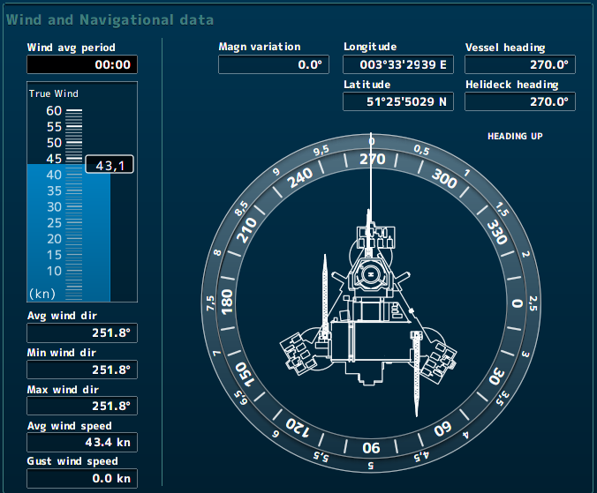

Figure 1‑15: Wind and navigational data

### Wind

Wind is a very important variable for the pilot to prepare the flight. In particular the wind speed and the gust wind speed are important. The explanation of the fields are as follows:

|  |  |
| --- | --- |
| Field | Explanation |
| Wind avg period | Setting of period for measuring average wind values |
| True wind | True wind real time |
| Avg wind dir | Average wind direction over a set amount of time |
| Min wind dir | Minimal wind direction over a set amount of time |
| Max wind dir | Maximal wind direction over a set amount of time |
| Avg wind speed | Average wind speed over a set amount of time |
| Gust wind speed | Gust wind speed over a set amount of time |

Table 1‑3: Wind explanation

Except for the true wind, all the other wind values are depending on the time you have set in the field “Wind avg period”. When you click on this field you will get a pop-up window where you can choose different period (see Figure 1‑16).

* Real time Real time values
* 2 minutes Average values over the past 2 minutes
* 10 minutes Average values over the past 10 minutes
* 20 minutes Average values over the past 20 minutes

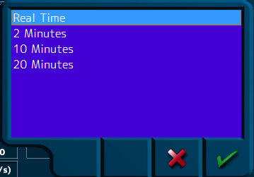

Figure 1‑16: Average wind period choice